**HERMES PARCEL DELIVERY**

Hermes is a parcel delivery platform. Here a user can either be a merchant or a customer. By using it a merchant can deliver a parcel to its customer. Merchant can login into the platform and have the detailed information of all the tables in the database. And the customer can track the progress of an order by the ordered.

* At first, in the homepage, there are two options,

1. Searching a order by the orderID
2. Merchant login using the username and the password.

To enlist a parcel, a merchant(shop) have to login using a username and a password (for example: Username - Apex, Password - apex123).



If the customer searches a order using the order ID then the platform will take to a page where the status of the order will be displayed

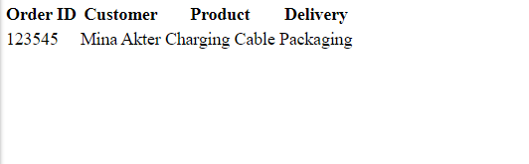

If the merchant logs in using the user name and the password, then the platform will take the merchant to the following page.

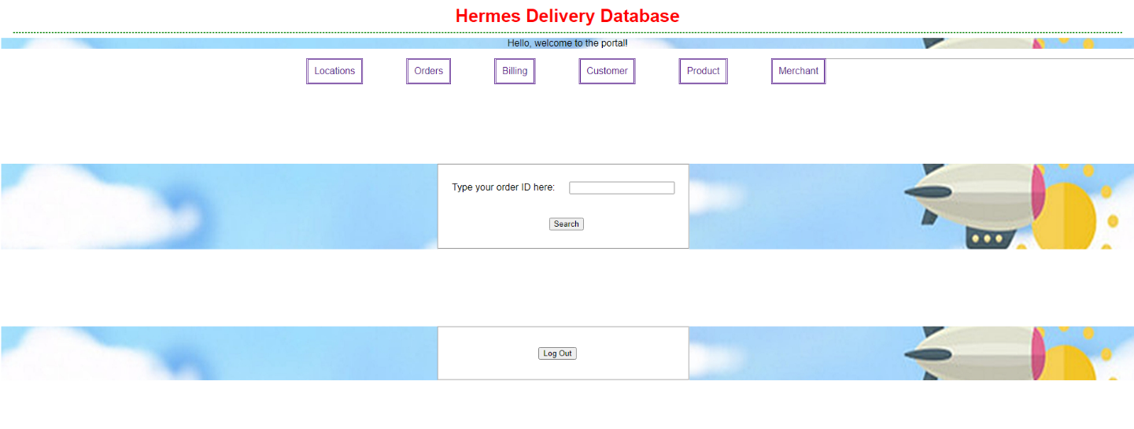

From here the merchant can search an order using the orderID. Access all the database tables regarding the locations, orders, billing, customers, products and merchants.

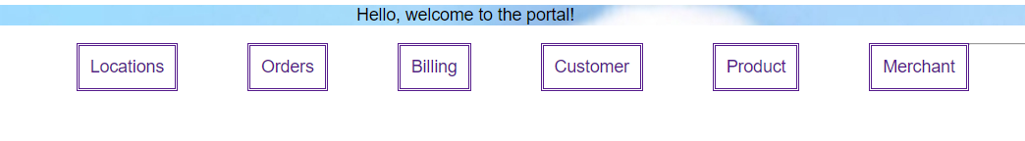

By clicking each of the tabs, the user can access the designated tables.

And to if a merchant clicks on log out it’ll redirect them back to the login page.

